**Azure Storage Accounts**

**Azure Storage Account**

An Azure storage account is a cloud-based storage service offered by Microsoft Azure. It provides a secure and scalable way to store and manage various types of data, including:

* **Blobs:** Unstructured objects like images, videos, audio files, and documents.
* **Files:** Shares accessible via SMB or NFS protocols, similar to traditional file servers.
* **Queues:** Messages that can be asynchronously processed by applications.
* **Tables:** NoSQL data stores for structured data.

**Key Features of Azure Storage Accounts:**

* **Scalability and Durability:** Azure Storage accounts can scale to massive amounts of data while ensuring high availability and durability through built-in redundancy mechanisms.
* **Security:** Data encryption at rest and in transit, along with robust access control mechanisms, protect your data from unauthorized access.
* **Cost-Effectiveness:** Pay-as-you-go pricing based on usage, offering flexibility and cost optimization.
* **Geo-Replication:** Replicate data across different regions for disaster recovery and improved availability.
* **Integration:** Seamlessly integrate with other Azure services, such as Azure Functions, Azure Data Lake, and Azure Machine Learning.
* **Performance:** High-performance storage options like Premium storage are available for demanding workloads.
* **Developer Tools:** SDKs, libraries, and tools are available for various programming languages and platforms, making it easy to interact with Azure Storage.

**Use Cases of Azure Storage Accounts:**

* **Media and Content Storage:** Storing and serving images, videos, and other media files.
* **Backup and Recovery:** Storing backups of on-premises or other cloud-based data.
* **Big Data Analytics:** Storing and processing large datasets for analytics and machine learning.
* **Web Applications:** Storing application files, user-generated content, and session data.
* **IoT Data Storage:** Storing and processing data generated by IoT devices.

**Note1:** The storage account name should be unique across all azure accounts or globally.

**Note2:** The storage account name should be 3-24 character long and all should be lower case and numbers only.

**Note3:** The maximum capacity of azure storage account is “500TB”, but it can be extendable base on our need or request.

**Let’s we discourse about the types of data that can be stored in Azure Storage-Accounts:**

Within an Azure Storage Account, you have several storage types to choose from, each designed for specific data needs and use cases:

* 1. **Blob Storage:**
  + **For:** Storing unstructured objects like images, videos, documents, and backups.
  + **Types:**
* **Block Blobs:** Primarily designed for storing unstructured data like images, videos, and large files.

Block blobs are made up of individual blocks of data. These blocks are then grouped together to form a single blob.

That means block blobs stores the data in the form blocks.

 A block blob can include or store up to **50,000** blocks.

Each block in a block blob can be a different size, up to the maximum size permitted for the service version in use.

|  |  |  |
| --- | --- | --- |
| **Service version** | **Max block size** | **Max blob size** |
| Version 2019-12-12 and later | 4000MB | ~190.7TB |
| Version 2016-05-31 through version 2019-07-07 | 100MB | ~4.75TB |
| Version previous to 2016-05-31 | 4MB | ~195TB |

Here each block can be identified by the Block ID.

**Features:**

It can store unstructured data like images, files, audio, and video & so on…

You can modify individual blocks within a blob without affecting the entire blob.

You can easily upload or modify individual blocks within a block blob without affecting the entire blob.

Well-suited for streaming scenarios where data is uploaded or downloaded sequentially.

Block blobs can scale to very large sizes (up to 5 TB), making them suitable for storing large files.

Block blobs can store files up to 4.75 TB in size, making them ideal for large media files, backups, and other large datasets.

Block blobs can be uploaded and downloaded in parallel, improving transfer speeds for large files.

* + - **Append Blobs:**

In Azure Storage, Append Blobs are a specialized type of blob designed for efficiently appending (adding) data to existing blobs.

That means it is ideal for scenarios where data is written in a stream or appended (added) to existing data.

Append blobs are composed of blocks, similar to block blobs, but with a focus on efficient append operations.

Appending data is a fast and efficient operation, as new data is simply added to the end of the existing blob content.

**Note:** You cannot modify or delete existing blocks within an append blob. Only new data can be appended. That means Updating or deleting of existing blocks is not supported.

Each block in an append blob can be a different size, up to a maximum of 4 MB. And an append blob can include up to 50,000 blocks.

The maximum size of an append blob is therefore slightly more than 195 GB (4 MB X 50,000 blocks).

* + - **Page Blobs:**

In Azure Storage, Page Blobs are a specialized type of blob designed for storing and managing large, random-access files.

Page Blobs allow you to read and write specific portions of the blob data directly, without having to deal with individual blocks.

Page Blobs are composed of 512-byte pages, enabling efficient random access and updates to specific parts of the data.

Commonly used to store Virtual Hard Disks (VHDs) for Azure Virtual Machines. This allows for efficient operation of the virtual machine's operating system and applications.

The maximum page blob size is 8TB. Each page size is 512-bytes.

* 1. **File Storage:** It is mainly designed to store the files by providing centralized storage to all the servers or machines (mainly used in case of migrating on-premises machines to cloud).
* Azure File Share is a service within Azure Storage Accounts that provides fully managed file shares in the cloud.
* Azure file share is a centralized storage or folder that can be mapped across multiple machines or servers.
* Azure File Shares can be accessed using standard industry protocols like SMB (Server Message Block) and NFS (Network File System). And Azure files REST API.
* **SMB protocol:** It allows seamless integration with Windows, Linux, and macOS Clients.

**Note1:**  SMB Azure file shares can be cached on Windows servers with Azure File Sync for fast access near. This azure File Sync allows you to sync your on-premises Windows Server file shares with Azure File Shares, enabling hybrid cloud scenarios.

* **NFS protocol:** It allows seamless integration with **Linux clients only.**

**Note2:** Azure File Share, enabling recovery from accidental deletion or snapshots allow point-in-time backups of file shares corruption. That means Azure file share can provide Backup by using snapshot concept in order to recover accidental deletion of files.

* Azure file share offering high availability, scalability, and durability.
* We can easily scale your file shares to meet the growing demands of your applications.
* Azure file share supports lift and shift scenario it enables us to move or migrate over data from on premise to cloud and vice versa.
* Azure file share provides both classic and hybrid lift and shift scenario’s.
* **Classic lift and shift:** Here both the application and its data are moved to Azure.
* **Hybrid lift and shift:** Here only the application data is moved to Azure Files, and the application continues to run on-premises.
* It is Integration with Azure Active Directory (Azure AD) for security & authentication.

**Note:** The maximum capacity of file in azure is 4.75TB.

* 1. **Queue Storage:** It is mainly designed to store messages that need to be processed asynchronously.

A service within Azure Storage designed for storing large numbers of messages that can be accessed from anywhere in the world via authenticated calls using HTTP or HTTPS.

A queue message can be up to 64 KB in size. It stores the message as text or binary data.

Enables applications to process tasks asynchronously, improving performance and scalability.

Handles millions of messages reliably and can scale to meet the demands of your application.

**FIFO (First-In, First-Out) Order:** Messages are typically processed in the order they are received, in order to ensuring predictable processing.

It enable asynchronous communication between applications.

* 1. **Table Storage:** It's designed for storing large amounts of structured **NoSQL data**.

**For:** Storing structured NoSQL data.

**Structure:** Organized as a table with rows and columns.

**NoSQL Data Store:** Stores data in a flexible, schema-less format.

**Key-Value Pairs:** Data is organized as entities with properties represented as name-value pairs.

**Scalability:** Can scale to handle massive amounts of data and high throughput.

**Simple Data Model:** Easy to use and understand, with a straightforward data model.

**Cost-Effective:** Relatively inexpensive for storing and querying large volumes of data.

Its scalability, flexibility, and cost-effectiveness make it a popular choice for various applications.

* 1. **Data Lake Storage Gen2:**
  2. **For:** Storing and analyzing massive datasets for big data analytics and machine learning.
  3. **Built on:** Blob Storage, offering high scalability and performance.
  4. **Integration:** Seamlessly integrates with other Azure data services.

The choice of storage type depends on the specific requirements of your application or workload. Consider factors like the type of data, storage needs, access patterns, and performance requirements when selecting the appropriate storage type within your Azure Storage Account.

**Storage account endpoints:**

A storage account provides a unique namespace in Azure for your data.

Every object that you store in Azure Storage has a URL address that includes your unique account name. The combination of the account name and the service endpoint forms the endpoints for your storage account.

There are **two types of service endpoints** available for a storage account:

1. Standard Endpoints.
2. Azure DNS zone Endpoints.
3. **Standard Endpoint:**

It is recommended endpoint in azure storage services.

By default, you can create up **to 250 storage accounts per region** with standard endpoints in a given subscription.

However with a **quota increase**, you can **create up to 500 storage accounts** with standard endpoints per region.

1. **Azure DNS zone Endpoints:**

By using Azure DNS zone Endpoints, you can create **up to 5000 storage accounts per region** with Azure DNS zone endpoints in a given subscription.

So from this, within a single subscription, we can create storage accounts with either standard or Azure DNS Zone endpoints, for a **maximum of 5250 accounts per region** per subscription. With a **quota increase,** you can **create up to 5500 storage accounts per region** per subscription.

**Note:** The maximum capacity of an Azure storage account is generally **500 TB (Terabytes)**. And it can be expanded based on our request.

Let’s create the storage account in azure free subscription:

Step1: create the resource group **“RG-1”.**

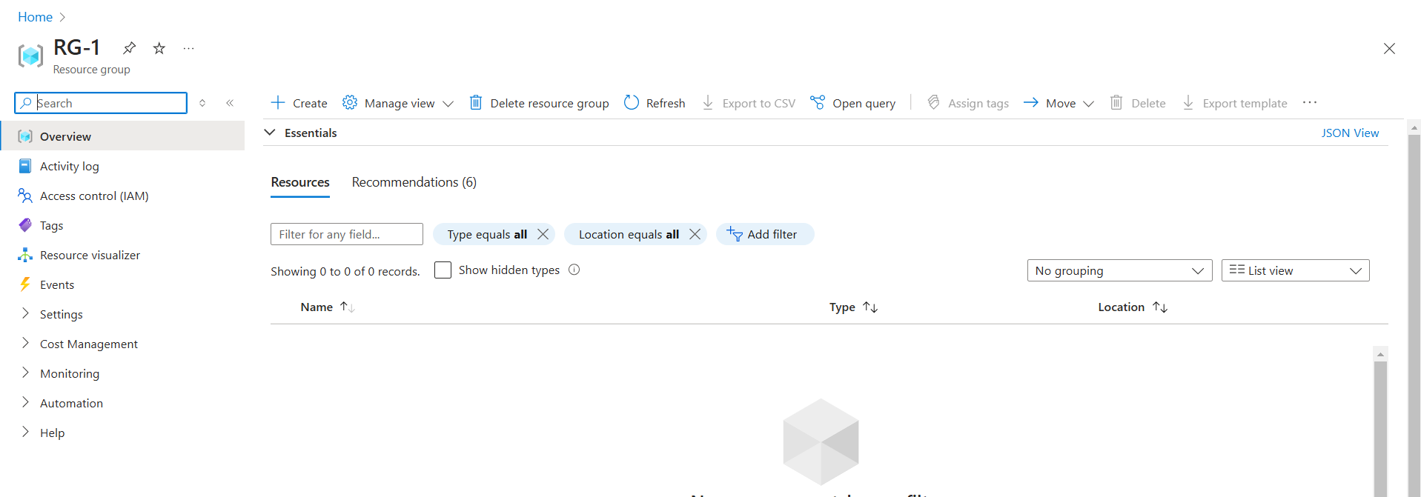

Before creating storage account we have to know about some topic like Redundancy techniques, access tiers and soft delete.

* **Redundancy techniques:**

In terms of computer science redundancy is refers to having multiple copies of the same object or component within a system. (In simple word **duplicating of our data**).

Azure Storage always stores multiple copies of your data to **protect it from planned and unplanned events** like hardware failures, network or power outages, and massive natural disasters.

Redundancy ensures that your storage account meets its **availability and durability** targets even in the face of failures.

Azure provides four types of Redundancy techniques or mechanism for storage account.

1. LRS

Redundancy in primary region

1. ZRS
2. GRS

Redundancy in secondary region

1. GZRS
2. **LRS:**

* LRS stands for local redundancy storage.
* It copies or replicates your storage account (data) three times with in a **single data center** (physical location).
* It provides **SLA** (service Level Agreement) at **least 99.999999999% (11 nines)** durability of object over a given year.
* LRS is the **lowest-cost** redundancy option and offers the **least durability** compared to other options.
* LRS **protects** your data against **server rack and drive failures**.
* If data center failed due to fire accident or floods then we cannot recover the data using LRS.

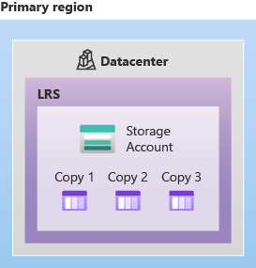

**Fig: LRS**

1. **ZRS:**

* ZRS stands for zone redundancy storage.
* It replicates your storage account **synchronously across three Azure availability zones** in the primary region as shown in below figure.
* For high availability of our applications requiring, **Microsoft recommends** using ZRS in the primary region.
* It provides or offers **SLR of 99.999999999% (12 nines)** durability of objects over a given year.
* ZRS provides excellent performance, **low latency, and resiliency** for our data.
* It cannot fully protect the data from regional disasters.

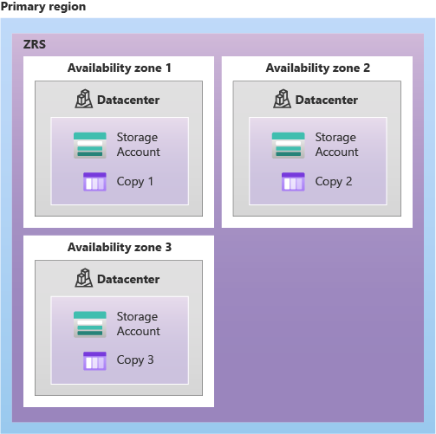

**Fig: ZRS**

1. **GRS:**
   * It stands for Geo-redundancy storage.
   * It copies or replicate our data **synchronously three times within a single data center** (physical location) in the primary region **using LRS**, and then it copies your data asynchronously to a single data center (physical location) in the secondary region.
   * That means the data can be replicated **asynchronously** from **primary region to the second region.**
   * Within the **secondary region**, your data is **copied synchronously three times using LRS.**
   * It offers or provides **SLA of 99.99999999999999% (16 nines)** durability over a given year.
   * GRS is a **high-availability and durability** option for Azure Storage accounts.
   * GRS is **more expensive** than Locally Redundant Storage (LRS) due to the additional cost of maintaining the secondary region.

**Advantages:**

* High-availability and durability.
* Robust Disaster recovery

**Disadvantages:**

* High cost.
* Replication lag.

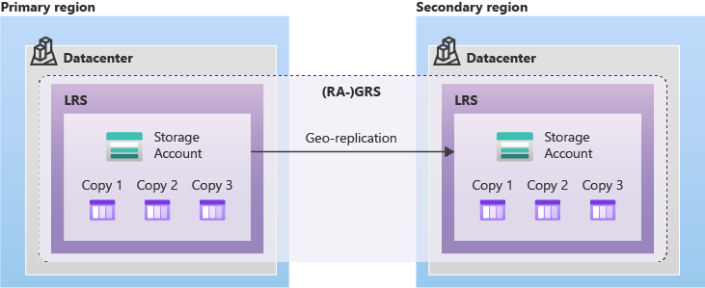**Fig: GRS**

GRS = LRS+LRS

1. **GZRS:**

It stands for Geo-Zone-Redundancy storage.

Data is replicated synchronously across three Azure availability zones within the primary region using Zone Redundant Storage (ZRS). And then the same data is replicated asynchronously to a single data center (physical location) in a secondary region.

It offers very high durability with SLA of 99.99999999999999% (16 nines) for a given year.

**Advantages:**

* High availability.
* Disaster recovery.
* Enhanced durability.

**Disadvantages:**

* High cost.
* More complexity.

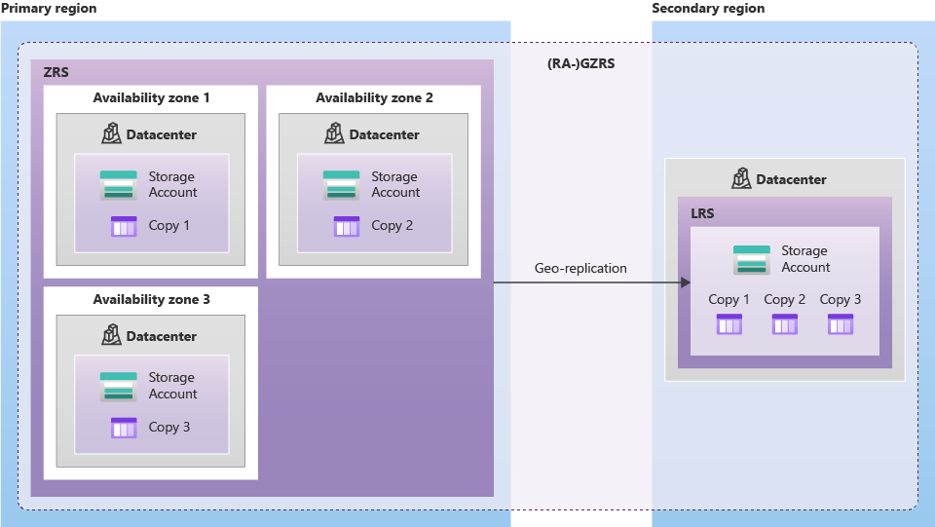

**Fig: GZRS**

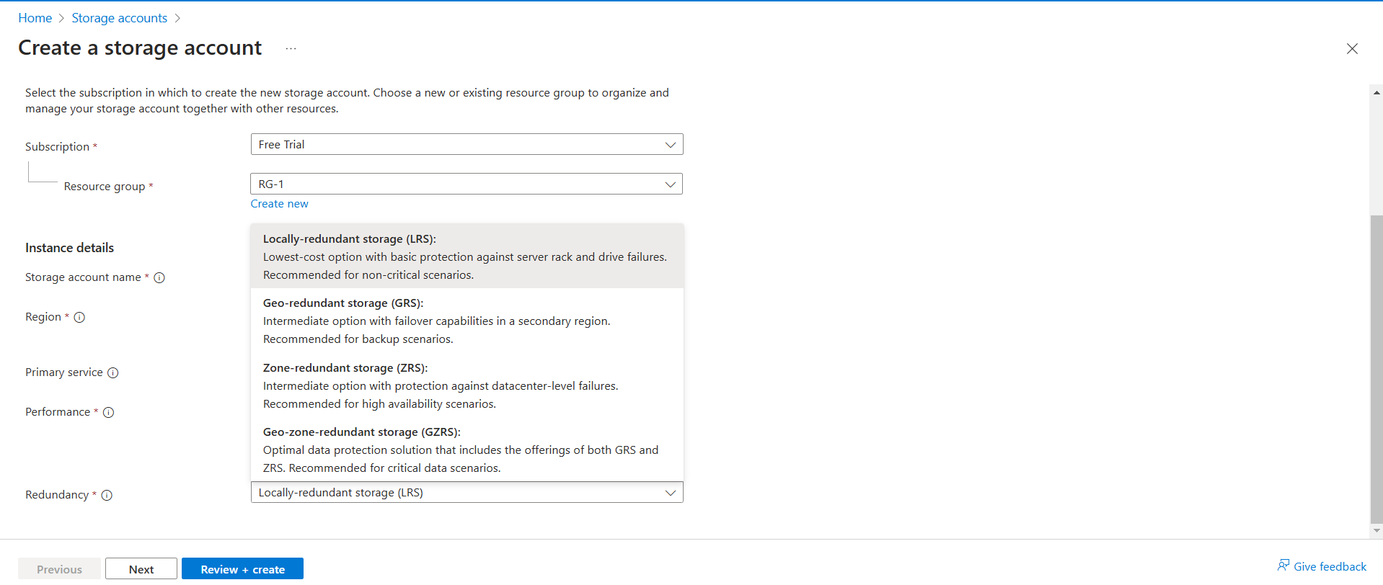

Fig: GUI view of Redundancy techniques

* **Access tiers:**

In Azure Storage Accounts, access tiers are a crucial feature that allows you to optimize storage costs based on how frequently your data is accessed.

So that you can store your blob data in the most cost-effective manner based on how it's being used.

Azure provides four different storage access tiers include:

1. Hot tier
2. Cool tier
3. Cold tier
4. Archive tier
5. **Hot tier:**

* Optimized for storing data that is accessed or modified frequently.
* Highest storage costs.
* Lowest access costs.
* Lowest latency and highest performance
* Suitable for active data that's read and written frequently.

1. **Cool tier:**

* Optimized for storing data that is accessed or modified infrequently.
* Lower storage costs than hot tier.
* Higher access costs compared to hot tier.
* Data in the cool tier should be stored for a minimum of **30** days
* Suitable for data accessed less frequently, such as backups, data archives, and infrequently used media.

1. **Cold tier:**

* Optimized for storing data that is rarely accessed or modified.
* Lower storage costs then cool tier.
* Higher access costs compared to the cool tier.
* Data in the cold tier should be stored for a minimum of **90** days.
* Suitable for long-term data archiving, such as legal or compliance requirements.

1. **Archive tier:**

* Optimized for storing data that is very rarely accessed**.**
* Lower storage costs then cold tier.
* High access cost then cold tier.
* Data in the archive tier should be stored for a minimum of **180** days.
* Suitable for long-term data preservation, such as historical records and backups.

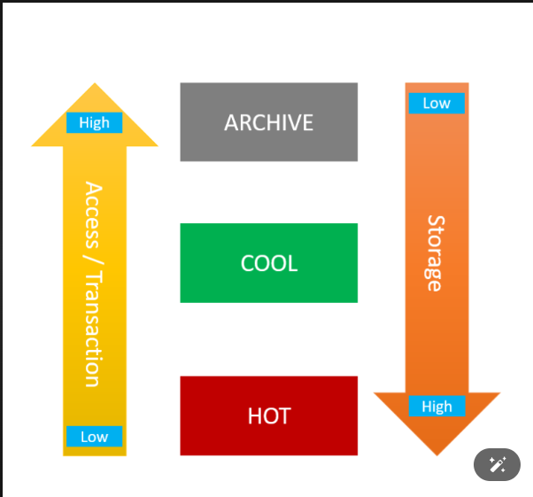

**Note:** Setting the access tier is only **allow** or applicable on **Block Blobs**. They are **not supported** for **append and page Blobs.**

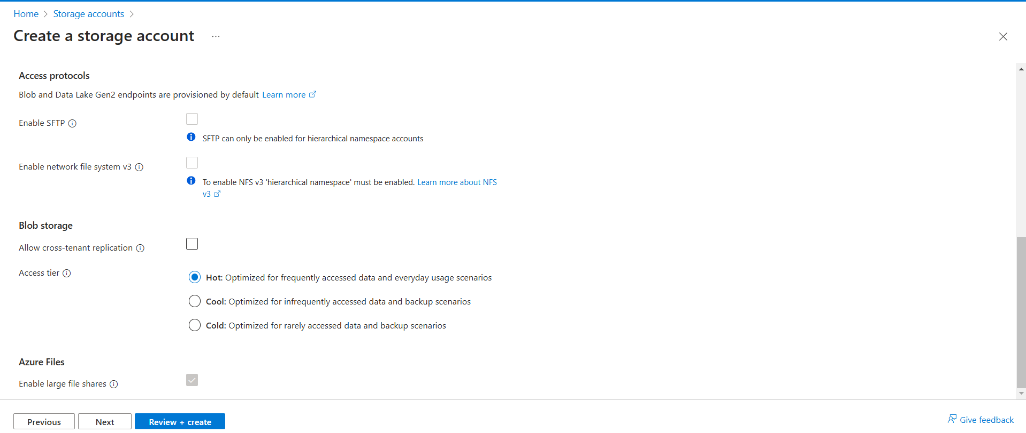

**Fig: Portal (GUI) view of access tiers**

* **Soft Delete:**

In Azure Storage, soft delete is a feature that prevents accidental data loss by keeping deleted data in a recoverable state for a specified period. Instead of permanently deleting data when it's deleted.

**Key aspects of soft delete in Azure Storage:**

* **Recoverability:** Soft-deleted, data can be restored within the configured retention period. This provides a safety net against accidental deletions or malicious actions.
* **Retention Period:** You can configure the retention period for soft-deleted data, typically ranging from 1 to 365 days.
* **Data Types:** Soft delete is available for various Azure Storage services, including blobs, files, and queues.
* **Control:** You can enable or disable soft delete at the storage account level.

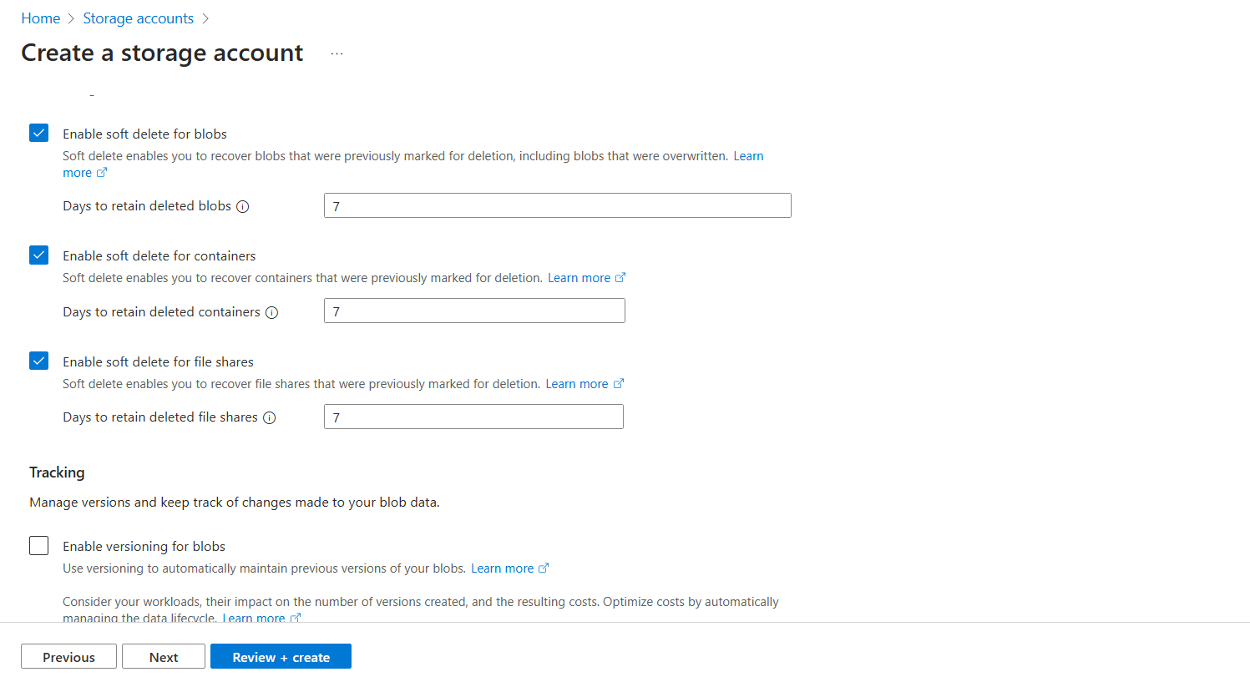

Fig: Enable soft delete by default is shows 7days.

Step2: Create the storage account.

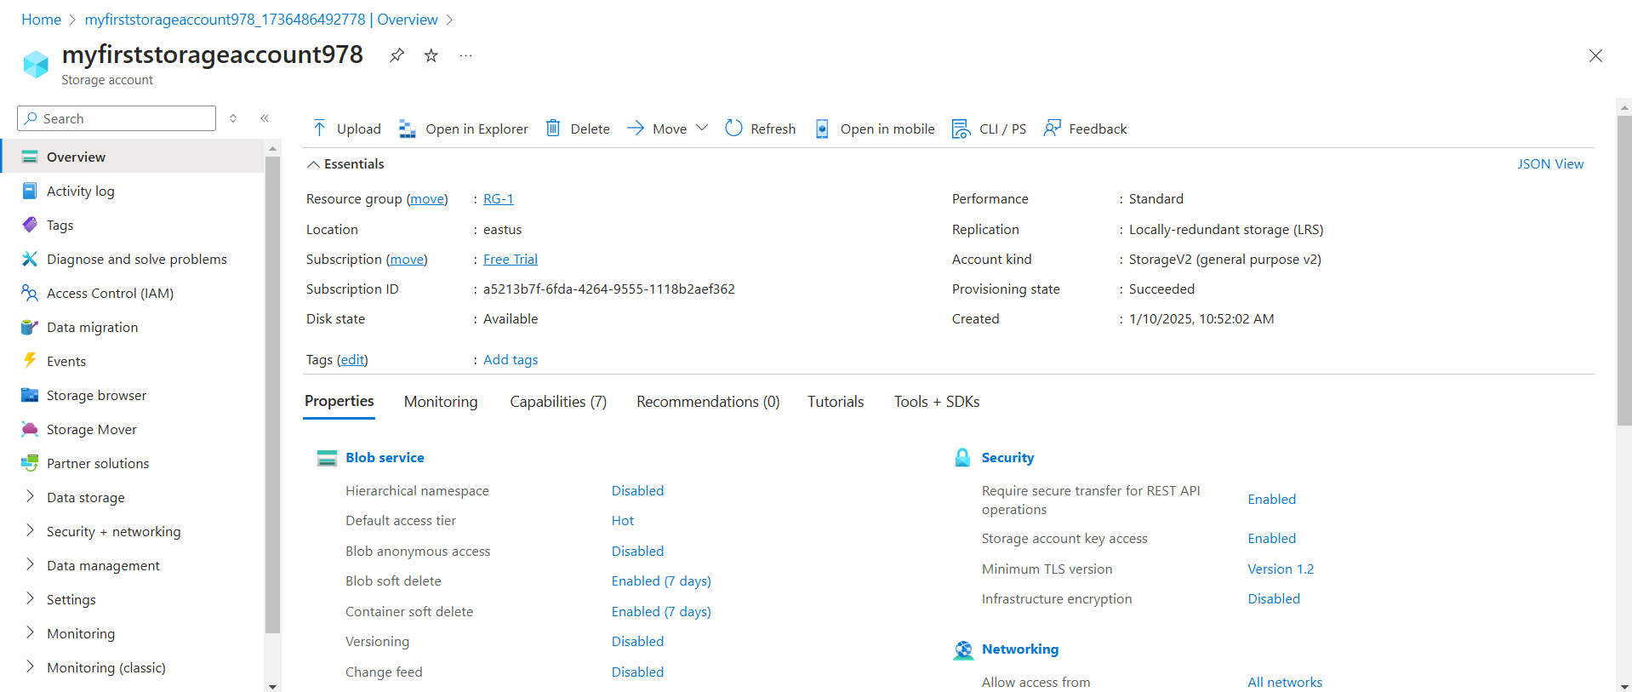

Fig: Storage account overview.